Independent dose verification of Brachytherapy plans using DICOM data exports

# Introduction

This document outlines the DICOM based TG43 calculation program I have written in python. It aims to independently calculate the dose based on the dwell positions within an Oncentra® RT DICOM Plan, and compare the resulting dose grid to an exported Oncentra® dose grid within an RT DICOM Dose file.

The code itself can be accessed from <https://github.com/SimonBiggs/teap-brachytherapy-portfolio/blob/master/TG43%20Implementation.ipynb> .

# The need for independent dose determination

A source of error of treatment delivery is the planning software and related planning processes. By including an independent determination of dose errors in the software and processes have an opportunity to be detected.

## Legislative independent treatment time calculations requirements

Within [ARPANSA RPS 14 code of practice](https://www.arpansa.gov.au/sites/g/files/net3086/f/legacy/pubs/rps/rps14.pdf) it states:

3.1.27 The Responsible Person must ensure that:

(d) patient-specific independent calculations of monitor units or treatment time are performed for radiotherapy

Within the [NSW government gazette number 51 of 9 April 2010](http://gazette.legislation.nsw.gov.au/so/download.w3p?id=Gaz_Gazette%20Split%202010_2010-51.pdf) the RPS 14 code of practice was adopted ender the Radiation Control Act 1990 by Joe Woodward making it is a legislative requirement within NSW that independent treatment time calculations are performed for radiotherapy.

## Example use of this code in the clinic

Given the open source nature of this code people can take the code and adapt it for their own use according to the AGPLv3.0+ license agreement. A physicist at John Hopkins in Baltimore USA has taken these steps to build and implement my code for use as a second check. He has set up a dicom server on a computer running the code, planners export the RP.dcm from Oncentra to this dicom server which then automatically runs the independent check and prints a report.

# Possible future direction

The following items of future direction depend directly upon ongoing community interest and time availability.

* Collect a range of brachytherapy DICOM files that are able to be placed within the Github repository that can be used for testing. Aim to support as many Brachytherapy DICOM formats as possible.
* Once egs_brachy (Chamberland, Taylor, Thomson, & Thomson, 2016) is available for use I would like to directly implement that dose calculation method to be able to provide checking for both TG43 and Monte Carlo based algorithms.
* It is also planned that upper and lower 95% confidence interval doses will be reported when uncertainties due to catheter movement, catheter reconstruction, and calculation uncertainties are taken into account. Using the Structure-Set DICOM file these 95% confidence interval doses can be converted to comparative DVHs.
* The final stage is for this code to rerun a dwell time optimisation to see if any plan improvement is possible and compare the robustness of the original plan to positioning uncertainties with the calculated comparative plan.

# Cautionary warnings

Brachytherapy DICOM files make use of a large number of private DICOM tags. What some of these tags mean needs to be reverse-engineered at times. This program has as of yet only been tested with Oncentra® DICOM files, not BrachyVision™ DICOM files. It has only been tested with a small subset of Oncentra® DICOM files. With some of these files (for certain configurations) this code does not yet work. Be sure when using this code to investigate the testing figures produced to confirm that they represent what is expected within the plan.

Pay particular attention to x,y,z definitions, catheter definitions, and source orientation.

# Method

## Source data

The Nucletron HDR remote afterloader Ir-192 source data used was retrieved from <http://www.estro.org/binaries/content/assets/estro/about/gec-estro/tg43-sources/new/ir-192/192ir-hdr-nucletron-mhdr-v2.xls>. It is provided as the consensus TG43 source data.

The source data is supplied to the program in the form of a range of CSV files. These files look like the following within the file browser:

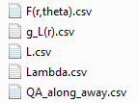

In that way by changing which version of these files the code is pointing to, a different set of source data can be used.

### Geometry

The consensus source data is based on the revised mHDR-v2 source model which is given below in Figure 1:

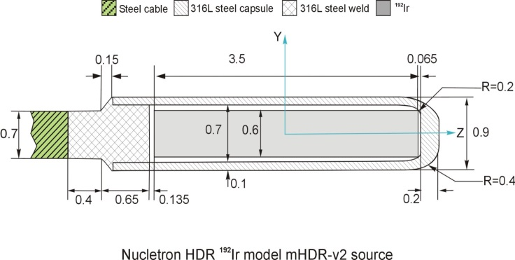

Figure : The revised Nucletron HDR Ir-192 mHDR-v2 source model

It has a length of 0.35 cm, according to this source data a dose rate constant of 1.109 cGy/(h U). The radial dose function data and the anisotropy function data are represented in Figure 2, Figure 3, and Figure 4.

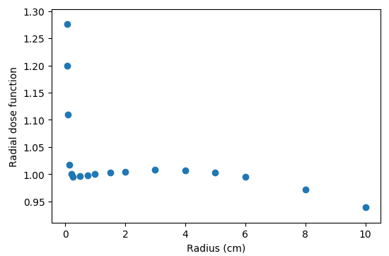

Figure : The radial dose function data

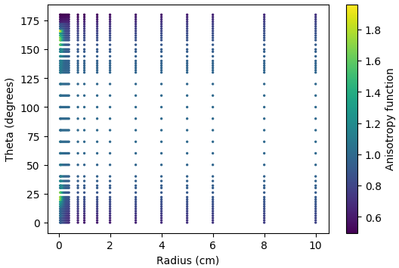

Figure : The anisotropy function data represented as a colour plot

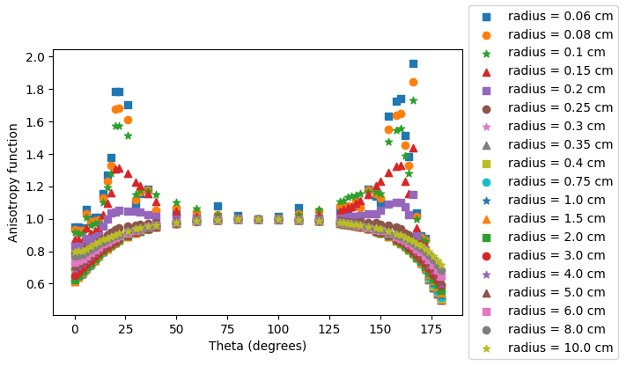

Figure : The anisotropy function data as a family of labelled points

## TG 43 implementation

The TG-43 implementation within the code follows the recommendations of TG-43U1S1 (Rivard, et al., 2007).

### Geometry function implementation

Implementation of the geometry function made use of a method within the literature (King, Anderson, & Mills, 2001).

In addition to implementation an interactive web app was produced (<https://www.geogebra.org/m/K25b5dNV>) to aid in the understanding of the differences between the point source and line source approximation as well as the effect of the updated protocols on the geometry function corner cases.

### TG-43U1S1 recommendations

TG-43U1S1 (Rivard, et al., 2007) provides recommendations for the implementation of TG-43. It explicitly provides recommendations for how to interpolate and extrapolate the data.

#### Radial dose function

The recommendations from TG-43U1S1 (Rivard, et al., 2007) for the radial dose function are the following:

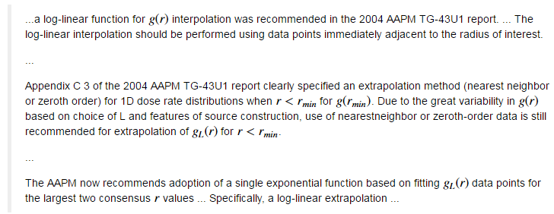

#### Anisotropy function

The recommendations from TG-43U1S1 (Rivard, et al., 2007) for the anisotropy function are the following:

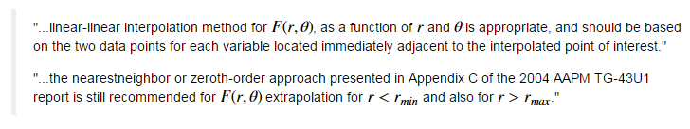

### Radial dose function interpolation

The resulting radial function interpolation and extrapolation can be seen in Figure 5.

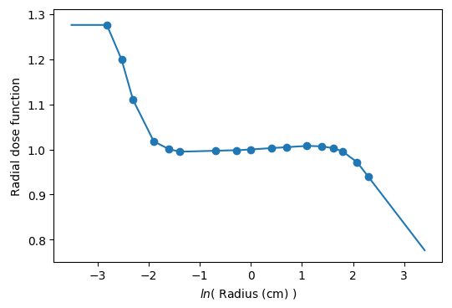

Figure : The interpolation of the radial function data

### Anisotropy function interpolation

The resulting anisotropy function interpolation can be seen in Figure 6 and Figure 7.

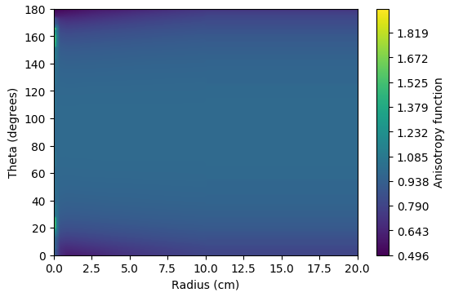

Figure : The interpolation of the anisotropy function represented as a colour wash

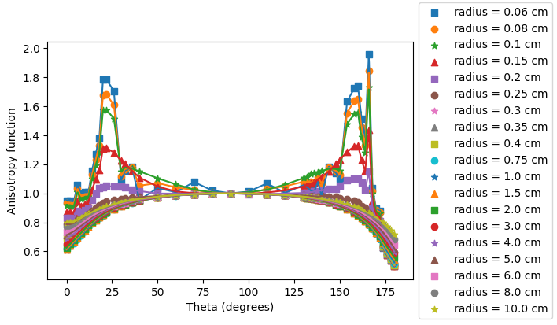

Figure : The interpolation of the anisotropy function represented as a family of labelled curves

## Testing of TG 43 implementation

The source data provided also comes with a set of “QA Along Away” data points. These grid points were input into the TG-43 calculation and compared with the reference results. The result of this comparison is given in Figure 8. The relative difference is less than 1% for all QA points. For all points greater than 0.6 cm from the source the relative difference is less than or equal to 0.4%. This QA result is within the interpolation error tolerance of 2% that is recommended by TG-43U1S1.

Of interest if a different length parameter of 0.36 cm is used the area close to the source agrees more with QA data provided (see Figure 9). Throughout this document however a length of 0.35 cm is still used in agreement with the consensus data.

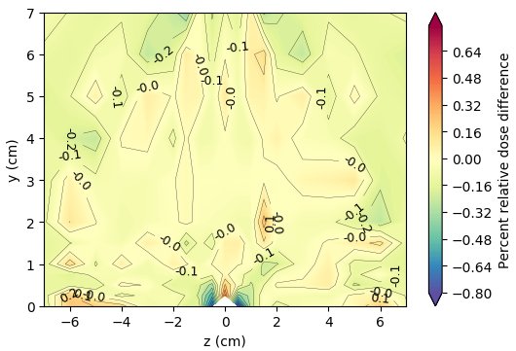

Figure : The results of the TG-43 implementation QA

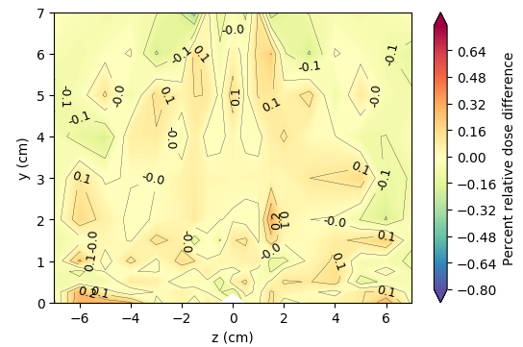

Figure : The result of the QA check when a length of 0.36 cm is used.

## DICOM plan file reading

To read the DICOM plans a large number of processes are required. To best understand how this is done one would need to go through the actual code itself (<https://github.com/SimonBiggs/teap-brachytherapy-portfolio/blob/master/TG43%20Implementation.ipynb>). For the purpose of this document a short overview of where the required information is found will be provided.

### Pydicom

To read DICOM files within Python a module called pydicom is available. Documentation for this module is available at <http://pydicom.readthedocs.io>.

The loading of the plan and dose DICOM files with pydicom can be achieved using the following code:

**import** **dicom**

dcm_dose = dicom.read_file("DICOM_dose_filepath.dcm", force=**True**)

dcm_plan = dicom.read_file("DICOM_plan_filepath.dcm", force=**True**)

### Reference Air Kerma Rate

Reference air kerma rate can by retrieved from the DICOM header using the following code:

**import** **numpy** **as** **np**

reference_air_kerma_rate = np.float(

dcm_plan.SourceSequence[0].ReferenceAirKermaRate) / 360000

### Dwell positions and Dwell times

The dwell positions and dwell times are stored within the following DICOM tag:

dcm_plan.ApplicationSetupSequence[0].ChannelSequence

A function is provided for the pulling of dwell positions, channels, and times. It is used in the following way:

dwell_positions, dwell_channels, dwell_times = pull_dwells(dcm_plan)

An example result from using this function is given in Figure 10.

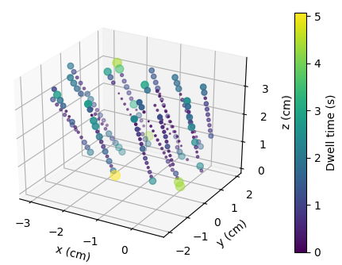

Figure : Extracted dwell positions and dwell times.

### Source orientation at dwell positions

Source orientation at dwell positions is determined using the catheter coordinates. Direction along the catheter depends upon tip end or end tip definition within the Dicom file. This is yet to be implemented however on initial investigation it appears that ApplicationSetupSequence[0][0x300b,0x1002] might be used for this. Further testing of this is required however.

A B-spline interpolation is made of the catheter coordinates and the derivative of this spline with respect to the spline parameterisation is then taken. This derivative is then converted into a three dimensional unit vector for each dwell position. This is the dwell direction.

A function is provided which determines the dwell directions. It is used as follows:

dwell_directions = determine_dwell_directions(

dcm_plan, dwell_positions, dwell_channels)

Dwell directions are printed out and displayed for each catheter. An example for the output provided for one catheter is given in Figure 11.

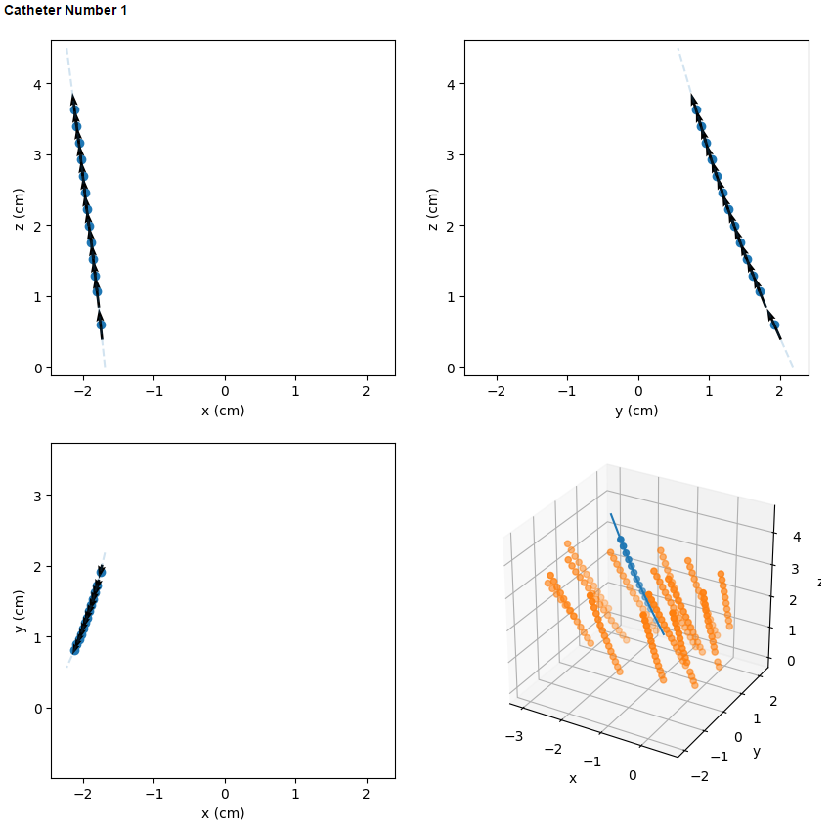

Figure : The dwell directions are displaced in x, y, and z directions for the user to verify dwell direction accuracy

## TG-43 usage

Once all of the required dwell information is extracted from the DICOM file the following implemented function can be used to calculate TG-43 dose:

tg43_dose = tg43_on_grid(

calc_x, calc_y, calc_z, reference_air_kerma_rate,

dwell_times, dwell_positions, dwell_directions)

## Comparison with DICOM dose

The calculation grid is extracted from the DICOM dose file. This calculation grid is then used for the TG-43 calculation. Once the calculation is complete a direct comparison is undergone between the calculated dose and the TPS dose.

Examples of these comparisons are given in Figure 12.

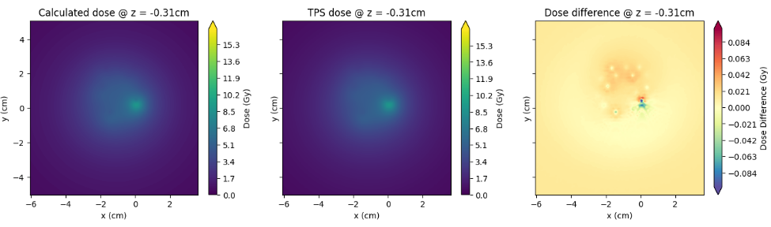

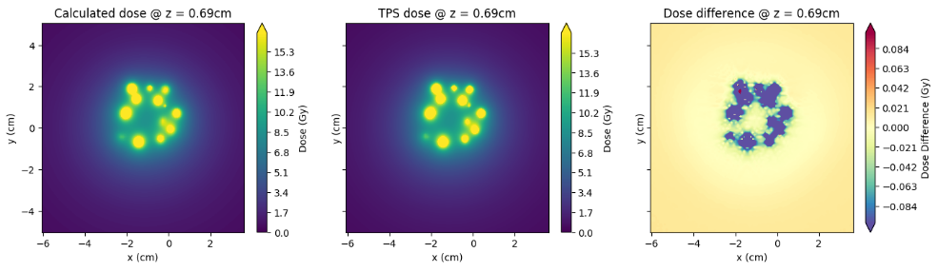

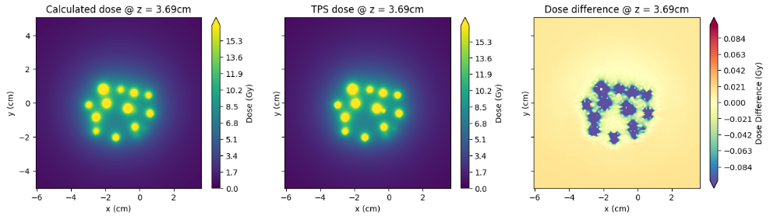

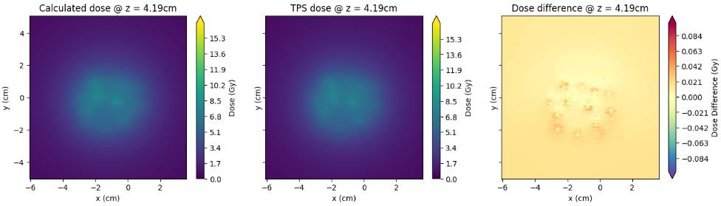

Figure : Dose differences between TPS and calculation for a range of slices.

# Conclusion

These initial results show promise regarding the method. Further investigation needs to be undergone as to the dose discrepancies close to the source. There likely will be benefit from using independently derived source data using egs_brachy (Chamberland, Taylor, Thomson, & Thomson, 2016).

This report has discussed the implementation within python of an independent dose calculation algorithm. Its ability to read and recalculate dicom files can fit well within the clinical workflow providing effective, efficient independent dose determination for brachytherapy plans.

# References

Chamberland, M. J., Taylor, R. E., Thomson, R. D., & Thomson, R. M. (2016). egs_brachy: a versatile and fast Monte Carlo code for brachytherapy. *Physics in Medicine & Biology, 61*(23), 8214. doi:10.1088/0031-9155/61/23/8214

King, R. P., Anderson, R. S., & Mills, M. D. (2001). Geometry function of a linear brachytherapy source. *Journal of Applied Clinical Medical Physics, 2*(2), 69–72. doi:10.1120/jacmp.v2i2.2615

Rivard, M. J., Butler, W. M., DeWerd, L. A., Huq, M. S., Ibbott, G. S., Meigooni, A. S., . . . Williamson, J. F. (2007). Supplement to the 2004 update of the AAPM Task Group No. 43 Report. *Medical physics, 34*(6), 2187-2205. Retrieved from https://www.aapm.org/pubs/reports/rpt_84S.pdf